Students Complaints Management System

Adekunle Y.Aa*, Okoro U.Rb, Abdulwahab A. Ac, Anya A.Nd

*a* *Bioinformatics Department, Babcock University Ilisan-Remo Ogun , Nigeria*

*b Computer Science Department, Babcock University Ilisan-Remo Ogun, Nigeria*

*a[adekunleya@gmail.com](mailto:adekunleya@gmail.com)*

*b okororaymond@ymail.com*

**Abstract**

**Customer Complaint is important information reflecting customers sound and is a primary measure of customer dissatisfaction. An effective and efficient response to these complaints is an essential index of organization’s performance. The presented model for the Student Complaint Management System will have the ability to minimize customers’ dissatisfaction and on the other hand it can encourage customers to participate in controlling the quality of the service provided. We try to improve the relationship between Students and the University by presenting a new model of e-Complaint web service based on SOA. The Proposed model aims to develop a Service-Oriented framework for e-Complaint Web-based that targets the incremental lifecycle. The cycle starts with requirements and solutions evolve through collaboration between self-organizing, cross functional teams. It promotes adaptive planning, evolutionary development, early delivery, continuous improvement and encourages rapid and flexible response to change. Therefore, a need for a system that could detect student’s problems and provide them with suitable feedback is raised. Also, this paper describes the Complaint Management System oriented by Web-application which will be used by students in order to make complaints about their dissatisfaction on provided services. This system will be able to handle complaints by recording and giving feedback for each raised complaint. Results of the study can be a good reference to find out users’ needs from e-complaint and the handling process of this complaint in the body of any organization.**

***Keywords:*** Customer Complaints Management (CCM), Customer Relationship Management (CRM),

E-Complaint, Service-Oriented Architecture (SoA)

1. Introduction

The key to building lasting customer relationships is to create superior value and satisfaction of the customers which can be achieved through effective customer complaint management system. Every cooperate must make complaint management system is one of the key strategies needed if they must succeed in their businesses [1]. The significance of customer complaint management system in the performance of corporate organizations cannot be overstressed. Customer complaints are inevitable in any corporate organization; no matter how good such an organization may be. Some complaints serve as a feedback mechanism for corporate organizations. Customers of such organizations may want to express their feelings and impressions on the quality of the product or service produced by the organization. Some complaints tend to relay a message on the taste and preference of the customers. Customers’ complaints become useful when such complaints attract quick and effective response from the organization. Corporate organizations are expected to hold their customers in high esteem since the customers are the lifeblood of any corporate organization. [2]

1. Customer Complaints Management (CCM)

In spite of the merits associated with the customer complaint management, several firms in Nigeria do not pay attention to customers complaints hence, customers are usually left alone to “lick their wounds” whenever there is a problem with the product they bought or services rendered to them. As a result of this, several firms in the country have lost their customers. This affects profitability and survival of such firms. Several firms in Nigeria have collapsed as a result of this unfortunate situation.[4][5]

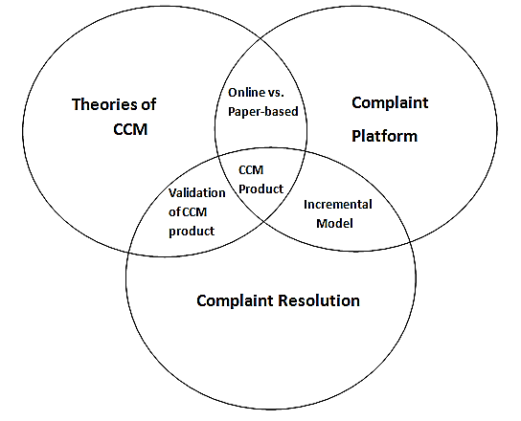Coupled with the foregoing, the use of information technology to manage customers’ complaints in Nigeria is at its infancy stage. Majority of the business organizations in the country use archaic or primitive methods to manage customers’ complaints. It is only few companies that use information technology or software to manage their customers. This has negatively affected the performance of such erring corporate organizations. There is evidently a wide gap between the expectation and the actual. However, this research work is designed to address these challenges which business organizations have in managing customer complaints.

Figure 1.Prefix theoretical framework adopted from [4]

1. System Design

System designed is a phase after system analysis, which specifies in details the structure or blueprint of the proposed system. After which current system has been studied to discover flaws and demerits, the new system is analyzed and designed to provide answers to problems which current system could not solve or solve efficiently. Design phase is very important because a majority of errors discovered during deployment and operation stages could be traced down to the system design

1. Methodology

The methodology or design model to be used is Incremental Development; it is a development approach. Strata Sampling technique was adopted. A Structured Questionnaire was administered to respondents. The Complaint Portal was further developed using tools such as: php, javascript, CSS, MySQL

4.1 **Research Design**

Research methodology refers to the overall methods employed by the researcher to assemble data for the study with a view to arriving at a scientific conclusion the methodology to be followed would be discussed under the following:-

i. Research Question

ii. Sources Design

iii. Sources of Data

iv. Population of the study

v. Area of study

vi. Sample and sampling technique

vii. Instrument for data collection

viii. Validity and Reliability of instrument

ix. Administration of instrument

x. Methods of Data analysis

1. Data Presentation and Analysis

This research work focuses on Student Complaints Management System (A Case Study of Babcock University). Adopting the concept of CCM where customers can be view to be the same term as *Students.* The analysis is based on the primary data collected through administered questionnaires .Views and Opinions of the respondents of the university would be used for this analysis. Twenty (20) officials were randomly selected across the various schools in the University and questionnaires were administered to them. Out of the twenty (20) questionnaires administered, the researcher was able to retrieve eighteen (18) questionnaires which were appropriately filled and used for this analysis. This constitutes 90% of the entire administered questionnaires.

1. Personal Data of the Respondents

In this sub-section, the personal data of the respondents would be analyzed.

## 6.1 Sex Distribution of the Respondents

Gender issues have become important contemporary issues which are being discussed globally especially in connection with technology.

Sex distribution of the respondents is presented in table 1 below:

Table 1: Sex Distribution of the Respondent (Sources: Field Survey, 2015.)

|  |  |  |
| --- | --- | --- |
| Sex | Frequency | Percentage |
| Male | 8 | 44.4 |
| Female | 10 | 55.6 |
| **Total** | **18** | **100.0** |

Table 1 above represents the distribution of the respondents by sex. From the table, 55.6 percent of the respondents were female while the remaining 44.4 percent were male.

## 6.2 Age Distribution of the Respondents

Age of a person determines his agility, resourcefulness and ability to manage issues especially complaints. The age distribution of the respondents is presented in Table 2 below:

Table .2: Age Distribution of the Respondents (Sources: Field Survey, 2015.)

|  |  |  |
| --- | --- | --- |
| Age Bracket | Frequency | Percentage |
| Below 20 | 0 | 0 |
| 20-25 | 1 | 5.6 |
| 26-31 | 5 | 27.8 |
| Above 31 | 12 | 66.7 |
| **Total** | **18** | **100.0** |

From Table 2 above, 66.7 percent of the respondents were over 31 years of age. This is followed by these between 26 and 31 years of age who constitute 27.8 percent of the respondents. Those that were between 20 and 25 years of age constitute 5.6 percent of the respondents.

## 6.3 Martials Status of the Respondents

Marital status is one of the most important aspects of demographic characteristics of respondents. The marital status of the respondents is presented in Table 3 below:

Table 3: Martial Status of the Respondents (Sources: Field Survey, 2015.)

|  |  |  |
| --- | --- | --- |
| Marital Status | Frequency | Percentage |
| Married | 16 | 88.9 |
| Single | 2 | 11.1 |
| Divorced | 0 | 0 |
| Widow/Widower | 0 | 0 |
| **Total** | **18** | **100.0** |

From Table 3 above, 88.9 percent of the respondents were married. The remaining 11.1 percent were either bachelors or spinsters.

## 6.4 Religion Distribution of the Respondents

Religion is another demographic feature of a sample. Religion may influence the kind of complaint raised by a person.

The distribution of the respondents according to their religion affiliation is presented in Table 4 below:

Table 4: Religion Distribution of the Respondents (Sources: Field Survey, 2015.)

|  |  |  |
| --- | --- | --- |
| Religion | Frequency | Percentage |
| Islam | 1 | 5.6 |
| Christianity | 17 | 94.4 |
| Traditional | 0 | 0 |
| **Total** | **18** | **100.0** |

From Table 4 above, 94.4 percent of the respondents were Christians. The remaining 5.6 percent represents the practitioner of Islam.

## 6.5 Complaints in an Organization

We have a complaint in an organization, when a stakeholder, especially, customers is unsatisfied with an issue concerning such an organization. In a university system, complaints may be raised by students, lecturers, parents or the general public.

Question 8B was raised to find out the inevitability of complaints

Question 8B: “Complaints are bound to occur in any organization especially in a university system”.

Responses to this question are presented in table 5 below:

Table 5: Responses to Question No. 8B (Sources: Field Survey, 2015)

|  |  |  |
| --- | --- | --- |
| Responses | Frequency | Percentage |
| Strongly Agree | 8 | 44.4 |
| Agree | 10 | 55.6 |
| Disagree | 0 | 0 |
| Strongly disagree | 0 | 0 |
| **Total** | **18** | **100.0** |

From Table 5 above, all the respondents 100.0 percent indicated that complaints are bound to occur in any organization especially in a university system. This affirmed the fact that complaints are inevitable in any organization.

## 6.6 Common Complaints Lodged By Students of Babcock University

Question No. 10B in the questionnaire was asked to identify the most common complaints lodged by the students of Babcock University.

Question No. 10B

“What are the common complaints lodged by the students of at Babcock "Responses to this question are presented in table 1.6 below:

Table 1.6: Complaints Lodged by the Students of Babcock University. (Sources: Field Survey, 2015.)

|  |  |  |  |  |
| --- | --- | --- | --- | --- |
| Complaints | No in Support | % | No Against | % |
| Complaints on course registration | 18 | 100.0 | 0 | 0 |
| Complaints relating to exam | 18 | 100.0 | 0 | 0 |
| Complaints relating to result compilation | 18 | 100.0 | 0 | 0 |
| Complaints relating to student welfare | 18 | 100.0 | 0 | 0 |
| Complaints relating to student lecturers relationship | 18 | 100.0 | 0 | 0 |
| Complaints relating to research projects | 18 | 100.0 | 0 | 0 |
| Complaints relating to lecturers | 18 | 100.0 | 0 | 0 |
| Complaints relating to school fees | 18 | 100.0 | 0 | 0 |
| Complaints relating to extra-curricular e.g sports | 18 | 100.0 | 0 | 0 |
| Complaints against university policies | 18 | 100.0 | 0 | 0 |
| Complaints from the public | 18 | 100.0 | 0 | 0 |

From table 6 above, all the respondents indicated that the common complaints lodged by the students of Babcock University include:

1. Complaints relating to examination
2. Complaints relating to result welfare
3. Complaints relating to student lecturers relationship
4. Complaints relating to research project
5. Complaints relating to lecturers
6. Complaints relating to school fees
7. Complaints relating to extra-curricular activities e.g. sports.
8. Complaints against university policies complaints from public

## 6.7 Effective Management of Complaints

Question No. 11 in the questionnaire was asked to find out how complaints can be effectively handled.

Question No. 11 “For stability and progress to be achieved, complaints must be effectively managed by the University”.

Responses to this question are presented in table 1.7 below:

Table 7: Responses to Question No. 11 (Sources: Field Survey, 2015.)

|  |  |  |
| --- | --- | --- |
| Responses | Frequency | Percentage |
| Strongly Agree | 16 | 88.9 |
| Agree | 2 | 11.1 |
| Disagree | 0 | 0 |
| Strongly disagree | 0 | 0 |
| **Total** | **18** | **100.0** |

From table 7 above, all the respondents (100.0 percent) indicated that for stability and progress to be achieved, complaints must be effectively managed by the university. This finding justified the research work.

## 6.8 Electronic Devices for Complaints Management

Question No. 12B in the questionnaire was asked to find out if electronic devices could be developed to manage complaints from the stakeholders at Babcock University.

Question No. 12B: “One of the most effective ways of managing complaints is to develop an electronic or mobile means for answers to some specific questions/ complaints”

Responses to the question are presented in Table 8 below:

Table 8: Responses to Question No.12N (Sources: Field Survey, 2015.)

|  |  |  |
| --- | --- | --- |
| Responses | Frequency | Percentage |
| Strongly Agree | 0 | 0 |
| Agree | 15 | 83.3 |
| Disagree | 1 | 5.6 |
| Strongly disagree | 2 | 11.1 |
| **Total** | **18** | **100.0** |

From table 8 above, majority of the respondents (83.3 percent) indicated that one of the most effective ways of managing complaints is to develop an electronic or mobile means for answers some specific questions or complaints. This finding revealed that customers’ complaints can effectively be managed through electronic means. However, 16.7 percent of the respondent had contrary view.

## 6.9 The Essence of Customer Complaints Management System

Question No: 14B in the questionnaire was asked to find out the essence of customer complaints management system.

Question No. 14B:

“Effective Customer Complaints Management System averts undesirable conflicts between the students and university” Responses to the question are presented in table 9 below:

Table 9: Responses to Question No. 14B (Sources: Field Survey, 2015.)

|  |  |  |
| --- | --- | --- |
| Responses | Frequency | Percentage |
| Strongly Agree | 2 | 11.1 |
| Agree | 14 | 77.8 |
| Disagree | 1 | 5.6 |
| Strongly disagree | 1 | 5.6 |
| **Total** | **18** | **100.0** |

From Table 9 above majority of the respondents (88.9 percent) indicated that effective customer complaints management system averts undesirable conflicts between the students and university. This finding affirmed the significance of customer complaints management system in a university setting.

However, 11.2 percent of the respondents had contrary view.

## 6.10 Employment of Customized Software to Manage Customers’ Complaints

Question No.15 in the questionnaire was asked to find the extent at which Babcock University employs customized software to manage customers’ complaints. Question No.15: “To what extent does Babcock University employs customized software to manage customers’ complaints”

Responses to this question are presented in table 1.10 below:

Table 10: Extent at which Babcock University Employs Customized Software to Manage Customer Complaints (Sources: Field Survey, 2015.)

|  |  |  |
| --- | --- | --- |
| Degree of Employment of Customized software | Frequency | Percentage |
| Very High | 0 | 0 |
| High | 2 | 11.1 |
| Moderately | 16 | 88.9 |
| Low | 0 | 0 |
| Very low | 0 | 0 |
| **Total** | **18** | **100.0** |

From Table 10 above, majority of the respondents (88.9 percent) indicated that Babcock university employs customizes software moderately to manage customers’ complaints. This suggests that Babcock University needs to apply more extensively customize software to manage customers’ complaints.

However, 11.1 percent of the responses had contrary opinion.

## 6.11 Customers Complaints Management System and Performance of the University

Question No. 18 in the questionnaire was asked to find out the impact of the customer complaints management system on the performance of the university.

Question No. 18:

“The customer complaints management system has enhanced the performance of the university”

Responses to this question are presented in table 11 below:-

Table 11 Responses to Question No.18 (Sources: Field Survey, 2015.)

|  |  |  |
| --- | --- | --- |
| Responses | Frequency | Percentage |
| Strongly Agree | 6 | 33.3 |
| Agree | 7 | 38.9 |
| Disagree | 4 | 22.2 |
| Strongly disagree | 1 | 5.6 |
| **Total** | **18** | **100.0** |

From Table 11 above, majority of the respondents (72.2. percent) indicated that the customer complaints management system has enhance the performance of Babcock University. This finding further re-affirmed the significance of customer complaints management system especially in university setting.

However, 17.8 percent of the respondents had contrary opinion.

## 6.12 Challenges Associated with Customer Complaints Management System of Babcock University

Question No. 19B in the questionnaire was asked to identify the major challenges associated with customer complaints management system of Babcock University.

Question No. 19B: “What are the major problems associated with customer complaints management system of Babcock?

Responses to this question are presented in table 12 below:

Table 12: Challenges Associated with Customer Complaints Management System Babcock University. (Sources: Field Survey, 2015.)

|  |  |  |  |  |
| --- | --- | --- | --- | --- |
| Challenges | Yes | Percent | No | Percent |
| The customers complaint management software is not easy to develop | 15 | 83.3 | 3 | 16.7 |
| High level of computer literacy is required among the stakeholders for the system to work | 18 | 100.0 | 0 | 0 |
| It is very costly to operate | 16 | 88.9 | 2 | 11.1 |
| Network problem may impair operation | 18 | 100.0 | 0 | 0 |

Table 12 above represents the challenges associated with customer complaints manages system of Babcock University. From the table the challenges associated with custom complaint management system of Babcock University include the following:-

1. High level of computer literacy is required among the stakeholders for the system to work
2. Network problem may impair operation
3. It is very costly to operate
4. The customers’ complaint management software is not easy to develop.

## 6.13 Babcock University and Customer Complaints Management System

Question No. 21 in the questionnaire was asked to find out the place of customer complaints management system in the operation of Babcock University.

Question No.21 “Customer complaints management system makes it easy for the university to attend to various complaints at almost same time”

Responses to Question No.21 are presented in table 13 below:

Table 13: Responses to Question No.21 (Sources: Field Survey, 2015.)

|  |  |  |
| --- | --- | --- |
| Responses | Frequency | Percentage |
| Strongly Agree | 3 | 16.7 |
| Agree | 8 | 44.4 |
| Disagree | 6 | 33.3 |
| Strongly disagree | 1 | 5.6 |
| **Total** | **18** | **100.0** |

Table 13 above shows the responses to question No.21. From the table, majority of the respondents (61.1 percent) indicated that customer complaints management system makes it easy for Babcock University to attend to various complaints at almost the same time. This finding also further stressed the significance of customer complaints management system in attending to various complaints at the University.

1. System Implementation

System implementation discusses the achievements of milestones set out in the development of the Customer Complaints Report System with graphic picture of components and explanation of how each component and page of the system works to perform system objectives as stated earlier

**7.1 Homepage:**

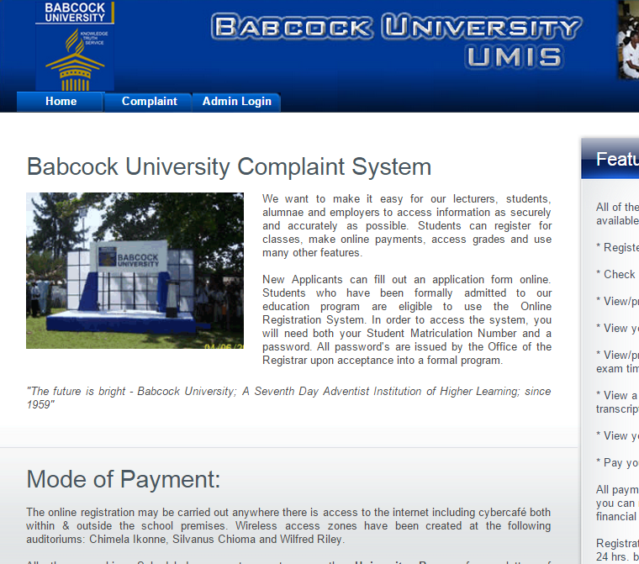When the user logs on to the online page, the home as shown in figure 2 gives a general description on what Babcock University Complaint System is all about.

Figure 2: Student Complaint Management Homepage showing the Complaint tab

Figure 2: Student Complaint Management Homepage showing the Complaint tab

Figure 2: Student Complaint Management Homepage showing the Complaint tab

**7.2 Authentication Page**

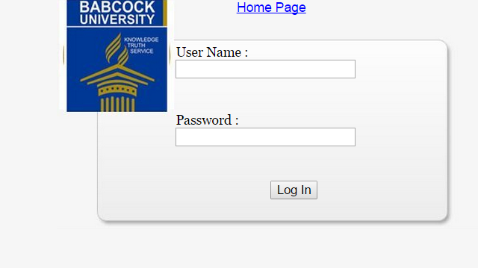On clicking the Complaint tab, the user is presented with a log-in page for verifiable username and corresponding password. The user can be end-user (student) or administrator (DBA)

Figure 3: Authentication page

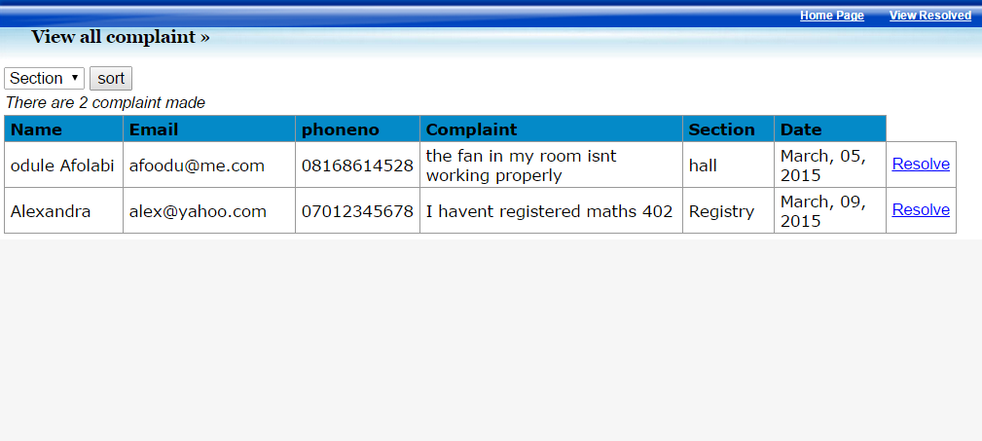

Figure 5: Complaint Dashboard for Admin

**7.3 DASHBOARD**

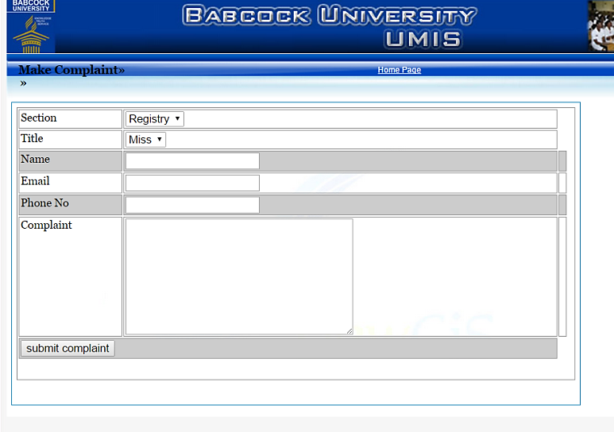Upon a successful log-in, a dashboard is presented either for lodging of complaints by students or actions options to be taken on lodge complaints by the admin. See figures 4, 5 and 6

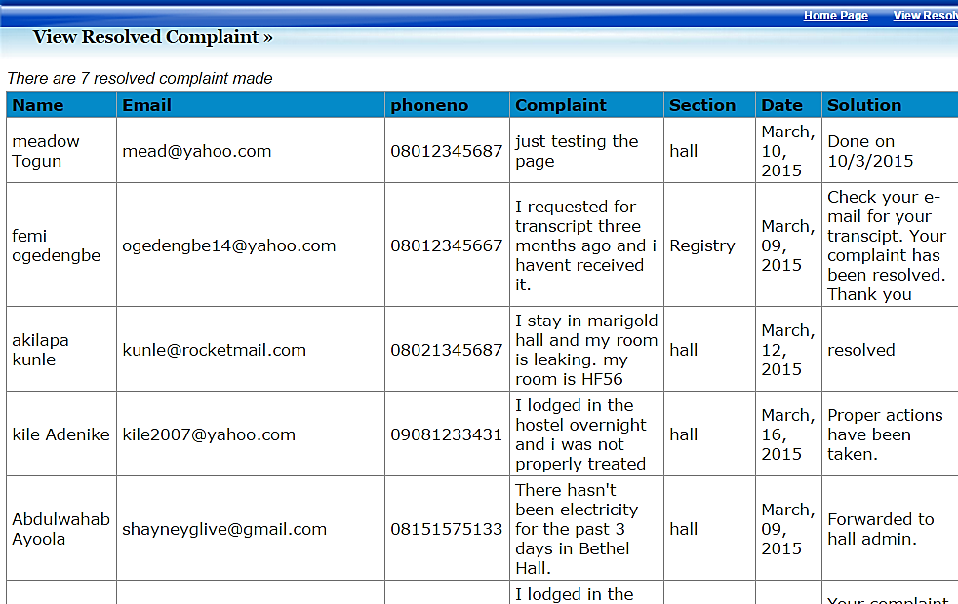Figure 4: Complaint Dashboard for Students

Figure 6: Complaint Dashboard for Admin showing resolved complaints made by Students

1. CONCLUSION

This research work addressed Students’ complaints management system in Babcock University, Ilisan Remo. It was affirmed in this study that organizational complaints are inevitable. A University system like Babcock use to receive various complaints from students. Complaints lodged range from Academic, Administrative, social and other issues relating to the student. This platform allows for complaints to be lodged remotely by students with issues relating to their registration, examination, examination result, computation of their Grade Point Average (GPA) and hall of residence complaints and thereby enhances the response time for the appropriate unit to resolve the addressed complaints.

References

[1] Claes F and Birger W; “A model for customer complaint Management” Marketing Science. Vol. 7 No.3 pp. 287-298. 1998

[2] Elijah E.O and Abdullahi U; “Imperatives of Customer Relationship Management in Nigeria Banking Industry” Kuwait chapter of Arabian Journal of Business and Management Review. Vol. 2 No.1 pp 60.62. 2012

[3] Okoro U.R *et al*; The cooperative prefix design approach-a worked sample-buhr mobile solution.ICACSET2014.Academia.edu/8721838/the_cooperative_prefix_design_approach. <https://babcock.academia.edu/OkoroRaymondUncleray>. 2014

[4] Brodgett J. G and Anderson R.D; “A Bayesian Network Model of the consumer complaint process” Journal of service Research Vol. 2. No 4 pp. 321-338. 2008

[6] Oliver R.L; “Satisfaction: A Behavioral Perspective on the consumer New York: McGraw- Hill companies. 2008